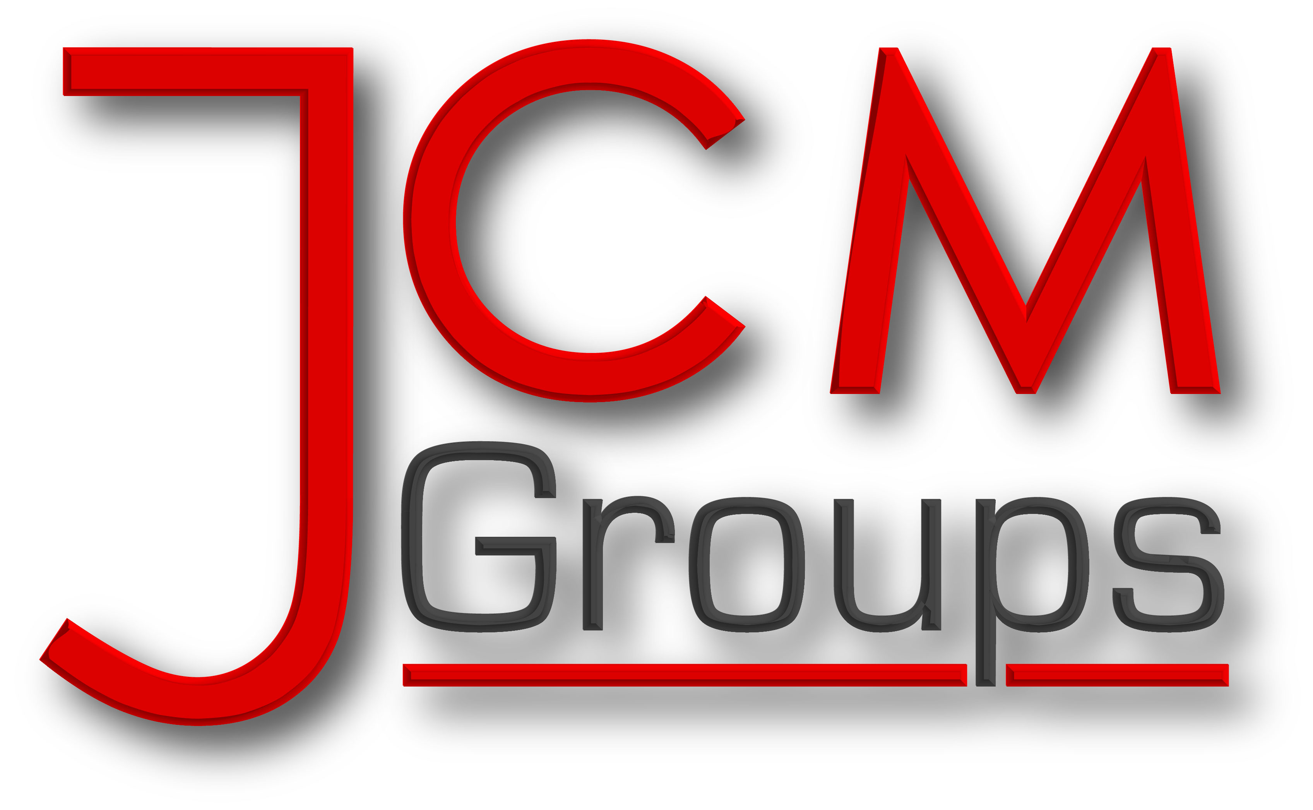

J.C MICHAEL GROUPS LTD NEWSLETTER

OCTOBER ISSUE
EDITORIAL
Welcome to another edition of our newsletter.
Its autumn again and I will like to thank everyone for your hard work in the summer month. Let’s keep up the good work.
Please remember we have duty of care, let this be our watchword. Let us continue to provide care with dignity and respect and be a blessing to our community.
Let us pull together to make J.C Michael Groups an excellent Care Provider.

***************** Florence Acquah
Word Search Puzzle

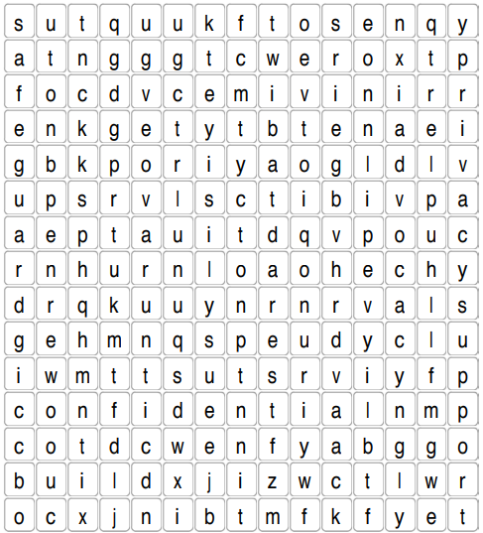

New Changes
It is mandatory for all the branches to ensure that all staff have an up to date Safeguarding Training. Also, any ad-hoc or refresher training must be completed on a monthly basis.

Survey
Watch out for the Employee Survey out on next week (29/10/18)! This survey will help SMT to improve concerned areas.

Audits
HR and Operations will continue to carry out their audits unannounced on a monthly basis.
Christmas Party
Watch out for more information in the coming few weeks! If you have any ideas on how to make the day wonderful, please email HR
Training
4-days Induction Training: Mondays - Thursdays Redbridge Branch. Wednesdays & Thursdays- split into 2 weeks: Croydon Branch.
Refresher Training: Redbridge and Croydon branch. Subject to availability. Alternatively, at your own local branch.
Specialist Training: Monthly Schedules are sent to Managers by HR. Ask your Managers for more information
All attendee’s details and results must be emailed to HR for certificate collection.
CROSSWORD HINT- SAFEGUARD

CONTACT US: Office Address: 2nd Floor, 56 Marsh wall Docklands E14 9TP

Email: admin@jcmichaelgroups.com

HR: hr@jcmichaelgroups.com. Complaints:Complaints@jcmichaelgroups.com

