J.C MICHAEL GROUPS LTD NEWSLETTER

wELCOME TO THE NEW FINACIAL YEAR 2018/19
EDITORIAL
Welcome to the New Financial year 2018/2019.
Thank you for all your work in the last financial period. I do know that you would have reflected on your output for 2017/18 which will be reflected in your Appraisal.
Be encourage that if the output is not what you are proud off, do use the new year as your opportunity to put in your best to achieve an excellent result.
Let us pull together to make JC Michael Groups an excellent Care Provider

***************** Florence Acquah
Word Search Puzzle

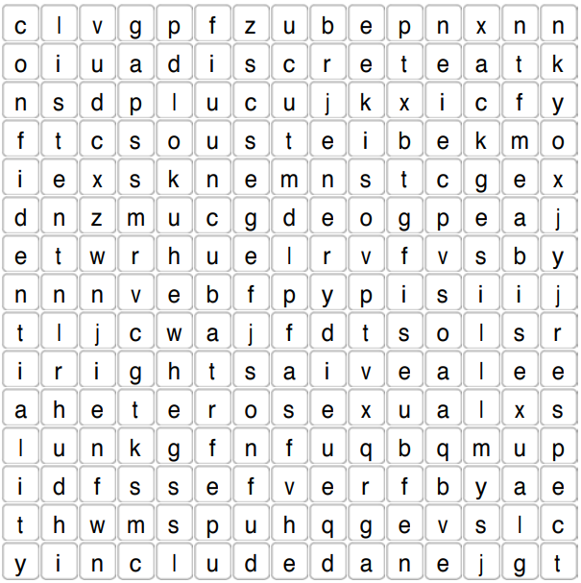

New Changes
New Annual Leave Sheet 2018/19 must be used to request all Annual Leave. All requests are to be made using the same form throughout the year. Any unauthorised form used to request Annual Leave, will be rejected as well as incorrect request protocols.

Tax Code
It is the new financial year, which means HMRC will be sending out new tax code to some employees. Please do let HR know if you receive or are issued with the above.

Appraisals
The deadline for Appraisal is in 3 weeks; 30.04.2018. Managers are to send their office staff Appraisals to HR by 30th April and ensure the matrix is updated and send to HR.
GDPR
General Data Protection regulation 2016 will be in full force on 25.05.2018. Consent to hold data for Service Users and Carers is paramount. So, ensure consent forms are signed by stakeholders. HR is still working on more information. Any queries, please contact HR or your Registered Manager.
Training
Induction Training; Mondays & Tuesdays Redbridge Branch. Wednesdays & Thursdays: Croydon Branch.
Refresher Training: is Thursday at Redbridge at 10.00 am. All attendee’s details must be emailed to the nearest training location and copy HR. Call the office for the addresses 0208 5194089
Specialist Training: Monthly Schedules are send to Managers by HR. Ask your Managers for more information

CONTACT US: Office Address: 2nd Floor, 56 Marsh wall Docklands E14 9TP

Email: Aquaflo@jcmichaelgroups.com

HR: hr@jcmichaelgroups.com. Complaints:Complaints@jcmichaelgroups.com

